Exposure and Field Visits for Problem Identification

Innovision 2025:
Engineering Change Through Ideas with Innovation

Submitted by
Sudhir S (7376251CS428)


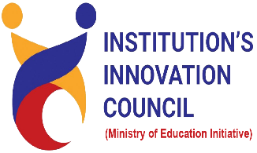

BANNARI AMMAN INSTITUTE OF TECHNOLOGY – INSTITUTION’S INNOVATION COUNCIL
&
Industry Exploration and Collaboration Cell

Duration: 18/10/2025 – 22/10/2025
ABOUT THE PROGRAM

Event Title: Innovision 2025: Engineering Change Through Ideas with Innovation
Duration: 187/10/2025 – 22/10/2025

The event aims to bridge the gap between real-world business challenges and innovative technological solutions. Innovision 2025 is a platform where creativity meets purpose. The event empowers students to tackle real-world problems through technology-driven innovation. Participants will collaborate, ideate, and present practical solutions that can make a tangible impact on society and industry. It’s not just about building prototypes — it’s about engineering meaningful change. Through detailed research and analysis, they will propose cutting-edge tech-driven solutions that enhance efficiency, reduce costs, and streamline processes. This initiative not only fosters problem-solving skills but also sparks potential startup ideas, paving the way for impactful innovations in various industries.

ABOUT THE STUDENT

S.NO | Description | Details
 | Name of the student | SUDHIR S
 | Register Number | 7376251CS428
 | Department | COMPUTER SCIENCE AND ENGINEERING
 | Year of study | FIRST YEAR
 | Contact Number | 7305080008
 | Mail id | sudhirs.cs25@bitsathy.ac.in
 | Location | GOBICHETTIPALAYAM

Problem Title:

Millets Value Chain Platform

1. Problem Statement (as per Smart India Hackathon)
Create a digital marketplace that enables farmers, Farmer Producer Organizations (FPOs), SHGS, startups, processors, and consumers to interact on a common platform.
2. Local Context – Field Visit Details
Block | Gobichettipalayam
Date of Visit | 21st and 22nd October 2025
Time of Visit | 04:45 PM – 07:30 PM
Team Members Present | Myself and Selva Karshan
Key Contact Person | Dr P Alagesan  Senior Scientist and Head of Programs  MYRADA KVK  (Mobile No. 9443897654)
Photographic Evidence - Link | Screenshot of online discussion:  Mrs. M Siva,  Senior Scientist – MYRADA KVK, Gobichettipalayam  Photograph of in-person interaction  Mrs. M Siva,  Senior Scientist – MYRADA KVK, Gobichettipalayam  Mr.Saravanan,  Kazhani Farmers Producer Company Ltd – FPO, Kallipatti
Permission Letter Reference | Telephonic calls made:  Dr P Alagesan - 9443897654  Mrs Siva – 9842748963  Mr Saravanan – 8344831718  Mrs Kavitha - 9942555081

3. Related SDG:

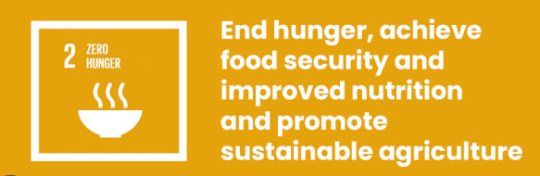

SDG 2 – Zero Hunger

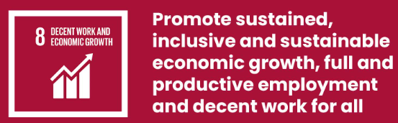

SDG 8 – Decent Work and Economic Growth

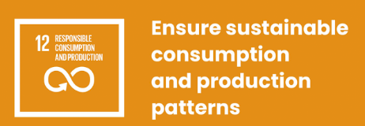

SDG 12 – Responsible Consumption and Production

4. Observations During Visit
- Production / Sourcing Trend:
Local Farmers: Finger Millet, little millet, foxtail millet, and kodo millet cultivation is in resurgence in the block. There is no supply of any other millets as is required by the supply chain in the region. Few regions like the Kolli hills and Thalavadi hills have cultivation spots but do not meet required demand for the block.
External Sourcing: To meet year-round demand, FPOs procure millets from Karnataka and other neighboring states where production is high and storage facilities are better.

- Cleaning Practice:
Wet cleaning method that reduces shelf life and dry cleaning method that enhances shelf life.
- Post Harvest Handling:
  - Inadequate Drying facilities
  - Pest Infestations
  - Karnataka has better silos and moisture-controlled storage

- Value Addition Potential:
Krish Vigyan Kendra – conducts training programs on millet processing and value addition like millet flour, snacks and ready-to-eat items.
Kazhani Farmers Producer Company Ltd – an FPO of around 1200 farmers at Kallipatti handles value addition of millets in the block
- Market linkages through Packaging & Branding

Products are packaged for retail sale under FPO brands like “Kazhani” or “Yes Millets.”
Some FPOs target urban markets and e-commerce platforms for higher margins.

- Quotes from Field:
  - “I am unable to get what I need from this shop, supply is lesser,” — Mr. Kanthan, Worker.
  - “I pay more than what popular brands demand from me, but I am happy that I am consuming organic produces”- Mr. Sathyan, Govt. employee (Ward 6).
  - “I am unable to afford to the highly priced products but consume them once in a while” – Mrs. Ramakumari, Private Job.

5. Local Stakeholder Map
Group | People Met / Data Source | Key Inputs
MYRADA Official | Mrs. Siva,  Senior Scientist,  MYRADA KVK,  Gobi | Need digital marketing and fair pricing
Farmer / FPO | Mr Saravanan  Kazhani-FPO | Increase in cultivation area, storage facilities as in Karnataka
Consumers | 10 buyers (Gobi) | Prefer Millet Dough, snacks, ready-to-eat food items in reduced pricing
Startup enthusiasts | Mr Sivakumar | Need raw material traceability and logistics link

6. Real Needs Identified
• Platform should support Tamil interface and offline access.
• Enable direct farmer–buyer–processor interaction to eliminate middlemen.
• Must include traceability (QR code) to build trust in the supply chain.
• Should feature payment, logistics, and certification modules.
• Need a training component for digital literacy of farmers / FPOs and SHGs.
- Data Summary
Category | Observation | Local Reference
Farmers Interviewed | 10 | Kallipatti, Gobi Block
SHGs Met | 3 | Under TNSRLM Gobi Cluster
Startups Consulted | 1 | Startup Aspirant, Gobi
Avg. Millet Output per Farmer | 12–18 quintals/season | Gobi Block
Digital Awareness Level | Low | 30% own smartphones, 10% use agri apps

(All figures based on direct observation and stakeholder inputs.)

Technology Direction (Local Feasibility)
Component | Purpose | Availability
Mobile App Platform | User-friendly digital marketplace | BIT technical support
Cloud Database | Store produce and transaction data | AWS / Google Firebase
QR Code Integration | Enable farm-to-fork traceability | Easily implementable
UPI Payment Gateway | Secure transactions | Razorpay / Paytm
Local Language UI | Tamil version | In-house translation feasible

Estimated Prototype Cost: ₹8,500 – ₹10,000
Local Support: BIT TBI / Innovation Cell + Gobi FPO willing to pilot.

9. Reflection and Understanding
After spending almost three days with local stakeholders and surfing the internet, I understood that the real bottleneck is not unavailability technology support alone.
Through the field visit, I observed that the millet ecosystem in Gobichettipalayam faces a serious production gap. While demand for millets is growing, production remains low because farmers are reluctant to cultivate low-profit crops.
FPOs working on value addition face challenges in procurement, and the market for millets needs to expand through digital awareness campaigns and accessible pricing that benefits farmers, producers, and consumers alike.
A “Shree Anna Connect” platform could serve as a one-stop solution, linking production to markets, facilitating procurement for FPOs, raising consumer awareness, and enabling profitable and sustainable millet cultivation.

10. Next Steps
- Conduct focused group interviews with SHGs to refine platform features.
- Develop low-fidelity prototype screens (Tamil + English version).
- Test user interface with 5–6 farmers and 2 startups.
- Document transaction flow and potential impact.
- Prepare a concept presentation with visual stakeholder map.

11. Attachments
- Photo 1: Online Meeting with official – 21.10.2025
- Photo 2: In-Person interaction with technology support centre – MYRADA KVK – 22.10.2025.
- Interview Questions: https://docs.google.com/document/d/1-6Y859vZfvpjYWOvpPWc8fyEARasDYUf/edit?usp=share_link&ouid=110482844679581960233&rtpof=true&sd=true
- Photo 3: Store visit and In-Person interaction with FPO – 22.10.2025
- Google Map Screenshot: Route from BIT Campus for In-person interaction.

Declaration
I confirm that the data in this report was collected in person on 18 and 23 October 2025 at Gobichettipalayam Block and verified with the official mentioned above.
All photographs were taken by me using my own device, and the names of individuals were recorded with their consent for academic purposes only.
Name: Sudhir S
Department: CSE – 1st Year
Register No.: 7376251CS428
Signature: _________________
Date: 23 October 2025
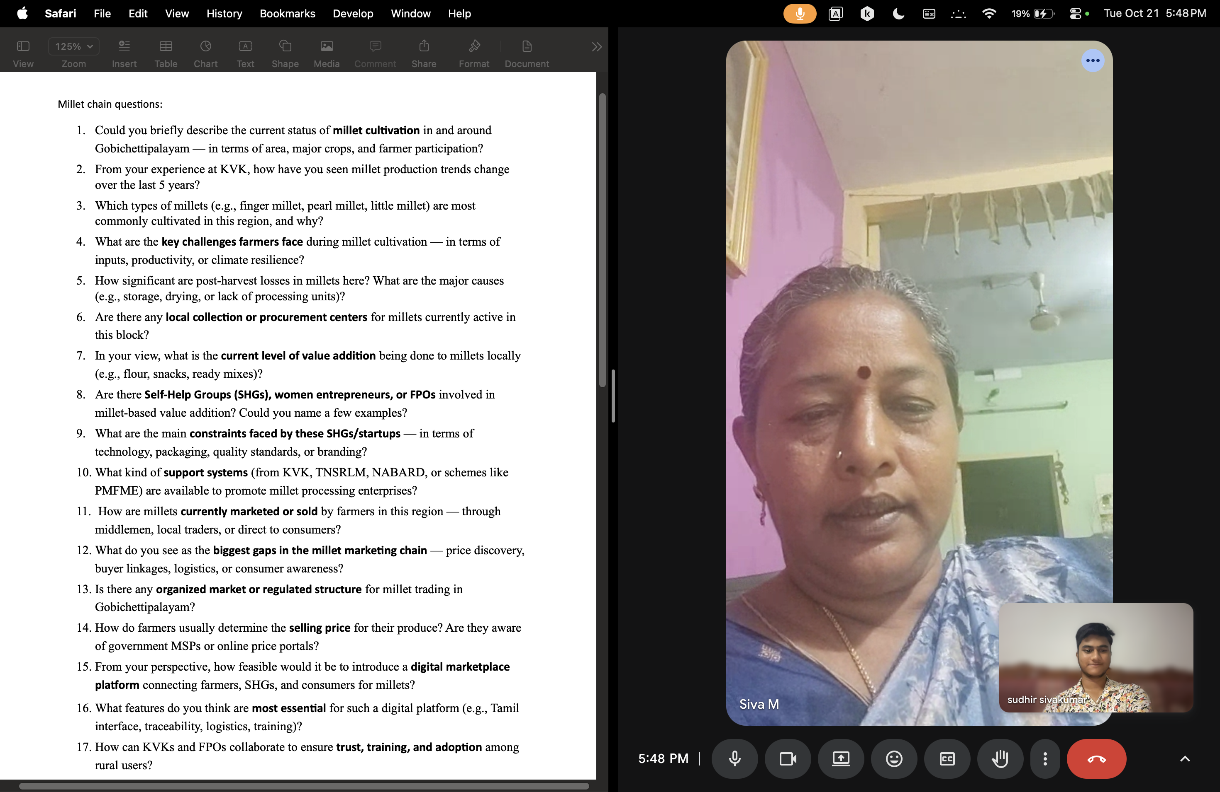
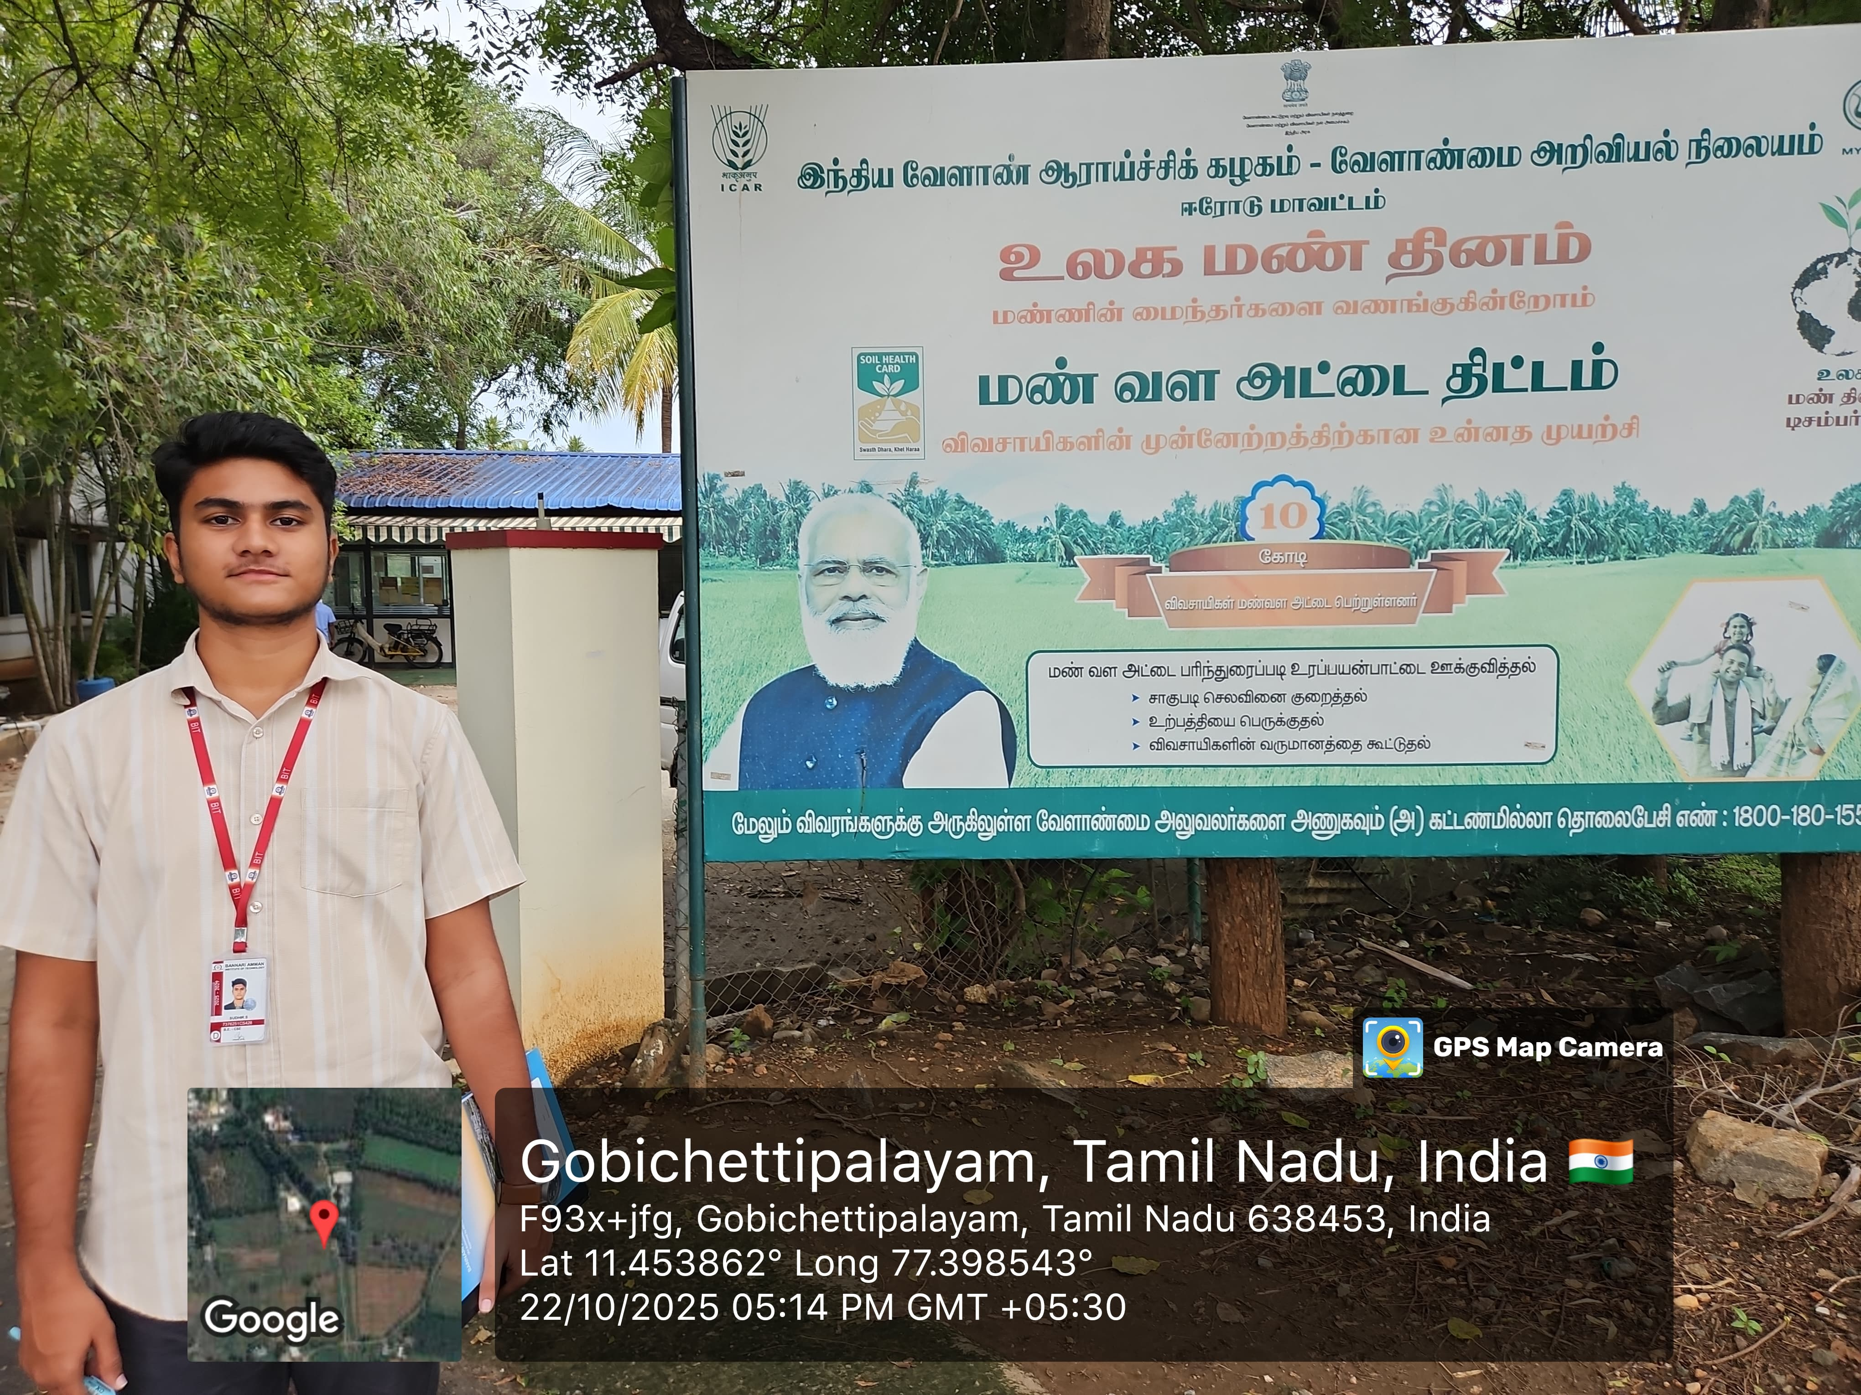
- Photo 1: Online Meeting with official – 21.10.2025

- Photo 2: In-Person interaction with technology support centre – MYRADA KVK – 22.10.2025.

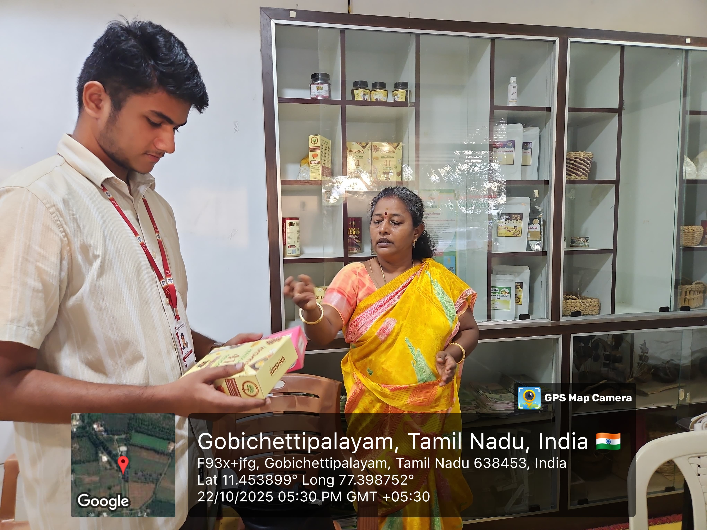
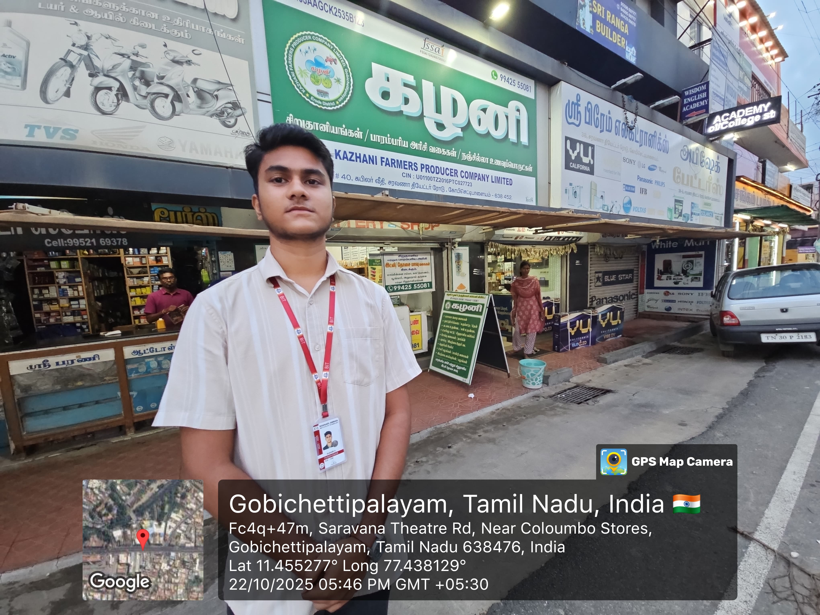
- Photo 3: Store visit and In-Person interaction with FPO – 22.10.2025
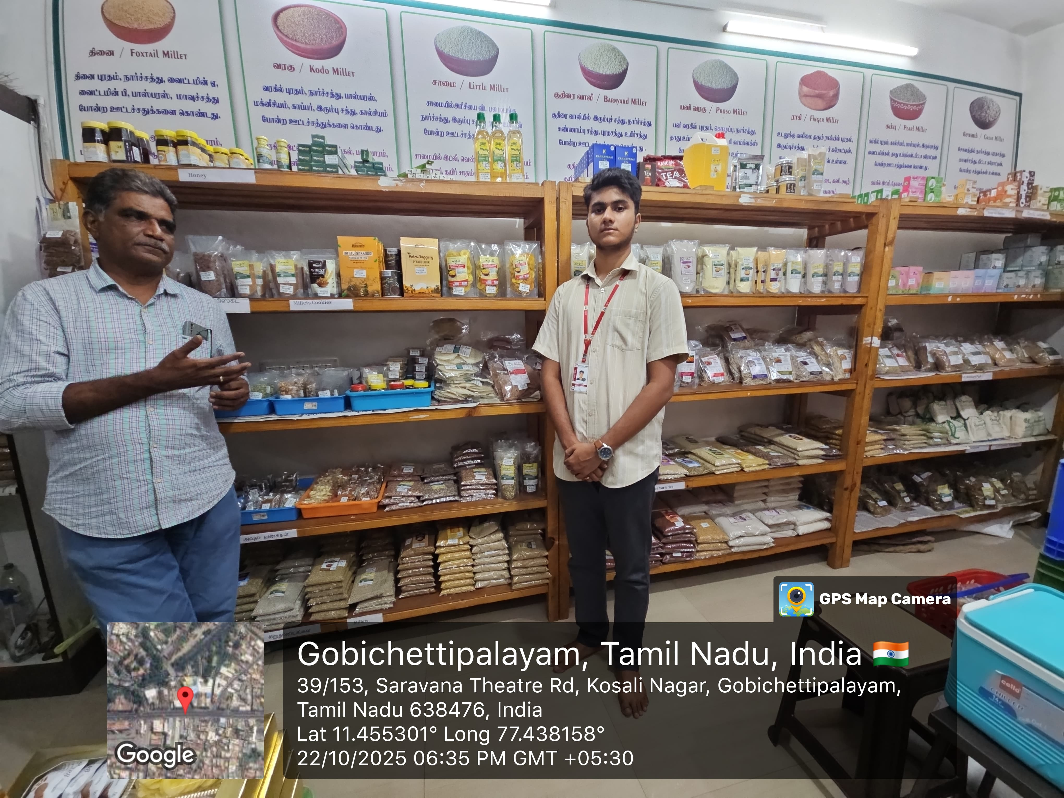
- Google Map Screenshot: Route from BIT Campus for In-person interaction.
